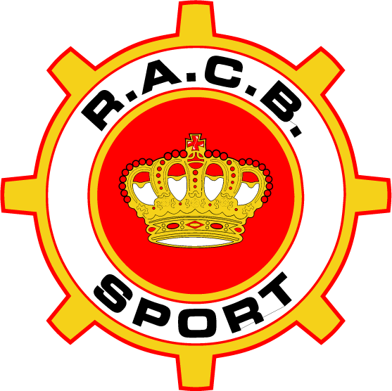  ROYAL AUTOMOBILE CLUB OF BELGIUM  WWW.RACB.COM | 2020 RACB Regulations for Safety cages manufacturer approval

Modified Article | Date of application | Date of publication
All | 14.04.2020 | 14.04.2020

ARTICLE 1 GENERAL
Every car that takes part to a competition under the authority of RACB must be equipped with a safety cage.

As the safety cage is a very important safety equipment, RACB is closely monitoring the design and manufacturing of this equipment.

RACB follows the international regulations edited by the Fédération Internationale de l’Automobile (FIA), specifically the “2020 HOMOLOGATION REGULATIONS FOR SAFETY CAGES”, “HOMOLOGATION REGULATIONS FOR HISTORIC ROPS” and Article 253 of the Annex J to the current FIA International Sporting Code.

RACB grants certificates and/or homologation documents to rollcages that have been manufactured according to the above-mentioned Homologation Regulations and that have been produced by RACB-approved manufacturers.

To apply for a RACB approval, a manufacturer must have undoubtedly demonstrated to RACB his consistent ability to design and manufacture safety cages which comply with the specifications approved by the FIA. The present regulations document describe what an applicant/manufacturer must meet in order to receive the RACB approval.

ARTICLE 2 DEFINITIONS
- A safety cage manufacturer applying for a RACB manufacturer approval, hereinafter referred to as "applicant"

- RACB manufacturer approval, hereinafter referred to as “approval”

- A RACB-approved safety cage manufacturer, hereinafter referred to as “manufacturer”

- Where "he" is referred to in this document, it may also mean "she" or a "legal person".

ARTICLE 3 MANUFACTURER APPROVAL
  - Only legal persons registered to the Crossroads Bank for Enterprises (CBE) can apply for an approval or the renewal of an approval.

  - A request for RACB approval is sent via email to lb.sport@racb.com and includes:
- Crossroads Bank for Enterprises registration extract, not older than two (2) months
- Justification for the reason why the applicant wants approval
- Statement that the applicant will manufacture safety cages in conformity with FIA regulations “2020 HOMOLOGATION REGULATIONS FOR SAFETY CAGES” and/or “HOMOLOGATION REGULATIONS FOR HISTORIC ROPS” and Article 253 of the Annex J to the FIA International Sporting Code.
- Description on the equipment and the welding process.

  - As part of the approval procedure, the RACB can have a welding test carried out by the applicant. The RACB will send the welding test to an independent institute for assessment. If the institute rejects the welding test, the applicant may submit a new welding test a maximum of two (2) times.

  - The approval is given “Intuitu personæ”.

  - RACB reserves the right to withdraw the approval if:
- the manufacturer produces less than three (3) homologated safety cages per year;
- the manufacturer does not abide by the applicable regulations;
- the manufactured safety cage fails a random control test;
- The manufacturer does not inform the RACB of a process change;

  - The granting, rejection or withdrawal of the approval is RACB sole decision.

  - RACB always grants approval for one (1) calendar year and it always ends on 31 December of the relevant calendar year.

  - Once the applicant has been approved, he receives from RACB a manufacturer number and a homologation certificate template.

ARTICLE 4 SAFETY CAGE MANUFACTURING REQUEST
  - Before the manufacturer starts manufacturing a safety cage, he must get a written agreement from RACB for the safety cage design. This agreement has to be requested before every safety cage manufacturing by sending the following information to lb.sport@racb.com :
- Safety cage design
- Car type, year of manufacture, discipline, and homologation number (if applicable)
- Safety cage material
- A strength calculation report of the roll cage (if applicable and according to current “HOMOLOGATION REGULATIONS FOR SAFETY CAGES” or “HOMOLOGATION REGULATIONS FOR HISTORIC ROPS”).

  - After approval of the design as described under 4.1. the manufacturer will receive a uniqueID number to put on the ID plate of the safety cage. The manufacturer can then manufacture the safety cage.

  - After manufacturing the safety cage the manufacturer provides the fully completed certificate template via lb.sport@racb.com. The RACB will then edit the official safety cage certificate and inform the manufacturer whether a random check is taking place or whether the roll cage is being released.

ARTICLE 5 COSTS FOR MANUFACTURER APPROVAL, SAFETY CAGE MANUFACTURING REQUEST AND SAFETY CAGE CERTIFICATION
  - The cost for the request for initial manufacturer approval is 1.500 €. The cost for approval renewal is 750 €. If the applicant had no manufacturer approval for more than the past two (2) calendar years its application will be considered as a first request.

  - A welding test is included in the costs stated under 5.1. If a second or third welding test is needed, the RACB Sport will charge the costs to the applicant.

  - The costs as referred to under 5.1. and 5.2. must be paid before the RACB Sport conducts the welding test.

  - The certification cost for each safety cage is 100€. Costs for an eventual sample will not be charged.

STATEMENT FOR SAFETY CAGE MANUFACTURERS

